Use Case Realisation Report - Manage ProjectPropose Project
FOR
Volunteer Management System
(VMS)

CLIENT
PROJECT | Volunteer Management System (VMS)
TITLE | Use Case Realisation Report - Manage Project
VERSION | 0.1a
DATE | 13-Aug-2011
 | ORIGINATOR
 | Name / Signature | Team 8S
 | APPROVAL
 | Name / Signature | Phung Kim Cuong, Dio
Institute of Systems Science |  | Document Reference
25 Heng Mui Keng Terrence  Singapore 119615 |  | VMS/T-1.4.1/1

 | Acceptance
 | Customer Signature |  | Customer Signature
 | Name & Designation |  | Name & Designation
 | Date & Company Stamp |  | Date & Company Stamp

Revision History

Date | Version | Description | Author
12-Jun-2011 | 0.1a | Creation | Team 8S
 |  | Refer to amendment history

Table of Contents

1. Brief Description 3
2. Flow of Events 3
2.1 Standard Flow 3
2.2 Exceptions 3
3. Interaction Diagrams 4
3.1 Domain Collaboration Diagram: Propose Project 4
4. Participating Objects 4
5. Derived Requirements 4
6. Derived Requirements 4
ANNEX D Amendment History 4

Use-Case Realization Report
Propose Project

Brief Description
The use case enables registered user to propose new project.

Flow of Events
The standard flow of events for this use case and any exceptions are described in the following subsections. See section 3.1 for an overview of the participating Actors and Domain Objects.

Standard Flow

Precondition: User has logged in the system

This use case provides the user interface related functionality that will be provided to the User, as follows:
- When the Volunteer clicks ‘Propose New Project’ button on the ProjectListingScreen, ProjectListingScreen.proposeNewProject() is triggered and it will trigger ProjectController.proposeNewProject() method.
- ProjectController.proposeNewProject() will use ProposePojectScreen.show() to display the ProposePojectScreen to Volunteer
- The project proposal form will be displayed on the ProposePojectScreen, including the following fields:
  - Project Name
  - Project Description
  - Country
  - Location
  - Estimated Duration
  - Proposer
- The Volunteer can edit each filed and he/she can also upload supporting documents on the screen
- When the user click ‘Submit’, the ProposePojectScreen .OnSubmit() will be triggered and it will use ProjectController.proposeProject() to create and submit a new project proposal
- The ProjectController.proposeProject() will use the validateProjectProposal() to perform business validation of user input information.
- After validation, the ProjectProposal.create() method is triggered to create a new ProjectProposal object in the data persistence.
- ProposeProjectScreen.displayMsg() is used to display an confirmation message to Volunteer
- The use case terminates.

Exceptions
The following exceptions have been identified:
- Invalid Information Format. If any of input info is incompatible, system will give a validation summary for user to make corrections

Interaction Diagrams

Domain Collaboration Diagram: Propose Project
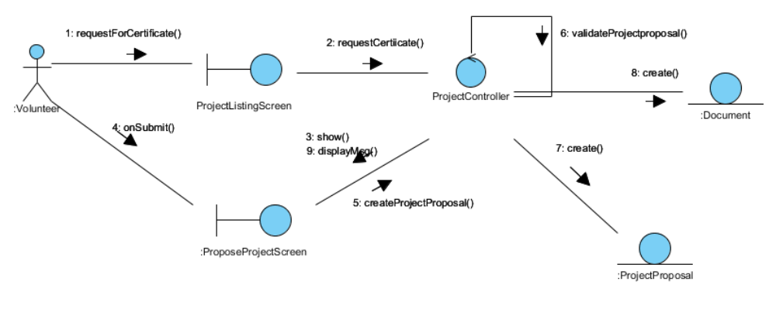

Participating Objects

Volunteer

This entity object stores the details concerning a volunteer of the volunteer organisation. The primary attribute that it holds is the userID.

ProjectProposal
This entity object stores the details concerning a project proposal that volunteer created. The primary attribute that it holds is the proposalID.

Document
This entity object stores the details concerning a document that volunteer uploaded. The primary attribute that it holds is the docID.

ProjectListingScreen
This boundary object is used for collection of project listing details. User actor uses this object.

ProjectProposalScreen
This boundary object is used for collection of project proposal. The Volunteer actor uses this object.

ProjectController
This control object co-ordinates the creation, update, viewing and searching project record in the volunteer management system. It receives requests from the boundary objects allocated for the specific purposes, along with all the necessary details required for the execution of these requests.

Class Diagrams

Class Diagram

:
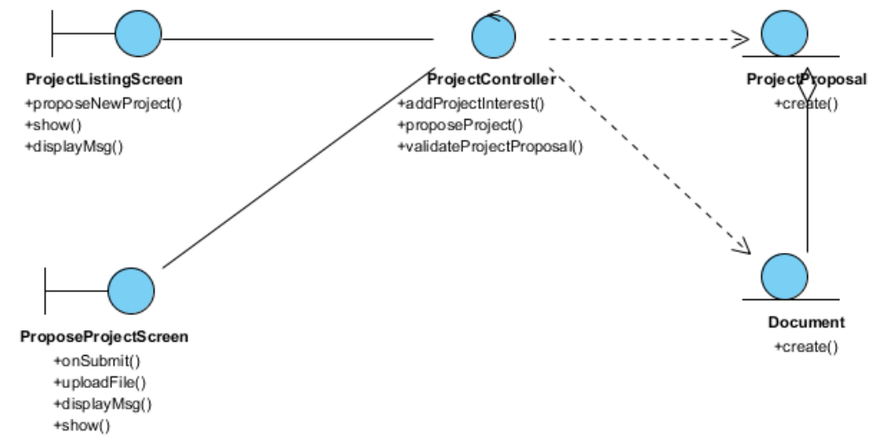

Derived Requirements

ANNEX D Amendment History

This is a record of all amendments made to the Document.
Version | Chapter / Section | Page No | Notes of Amendments or Changes

